Secure Coding Lab-11

Chekuri.mahesh 18BCN7101

L39+L40

# Lab experiment – Creating secure and safe executable

1. **C++ Code & building the Executable**

#include <iostream>

int main(void)

{

int authentication = 0; char cUsername[10]; char cPassword[10];

std::cout << "Username: "; std::cin >> cUsername;

std::cout << "Pass: "; std::cin >> cPassword;

if (std::strcmp(cUsername, "admin") == 0 && std::strcmp(cPassword, "adminpass") == 0)

{

authentication = 1;

}

if (authentication)

{

}

else

{

}

std::cout << "Access granted\n"; std::cout << (char)authentication;

std::cout << "Wrong username and password\n";

return (0);

}

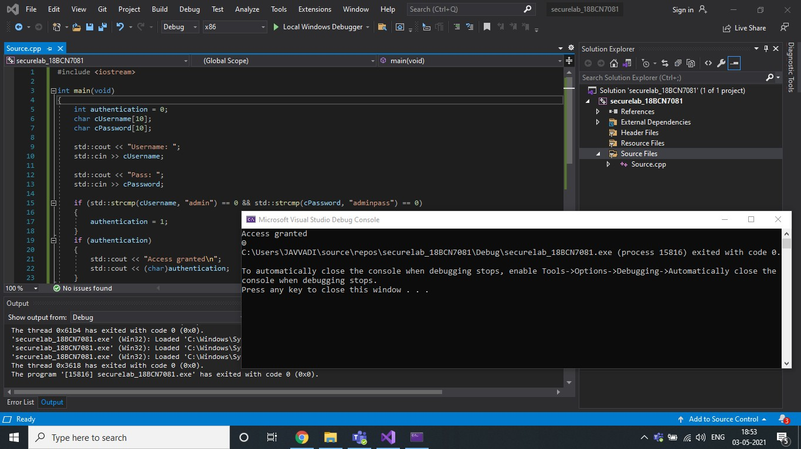

# Verifying the DEP & ASLR status in Process Explorer

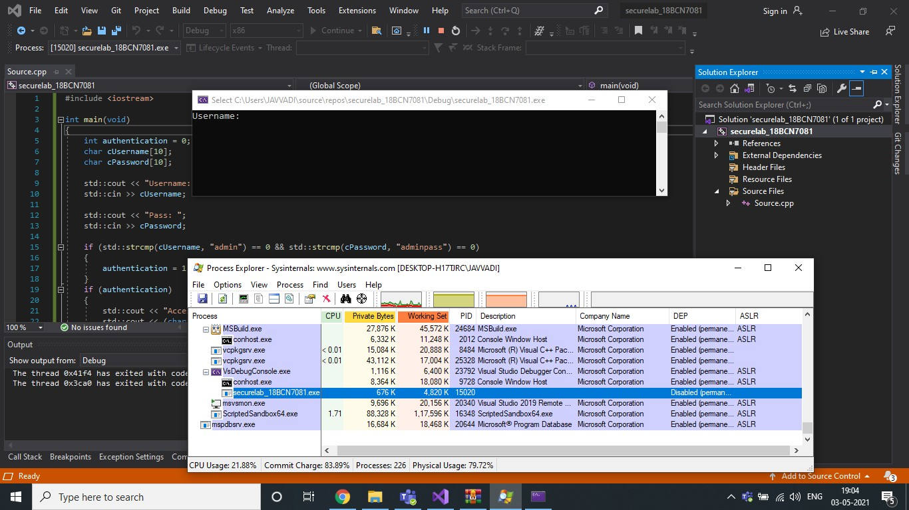

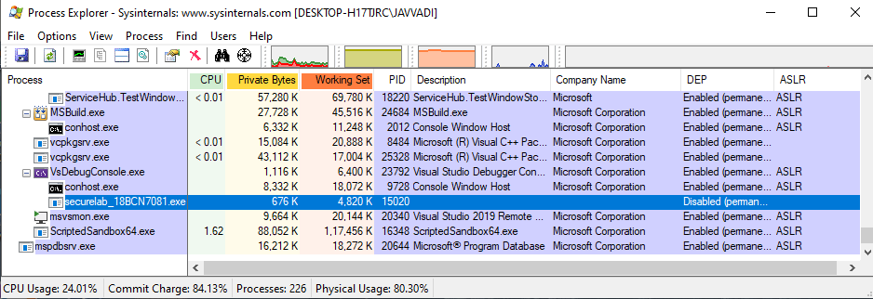

You can see DEP disabled & No ASLR.

# Rebuilding the same executable After enabling DEP & ASLR

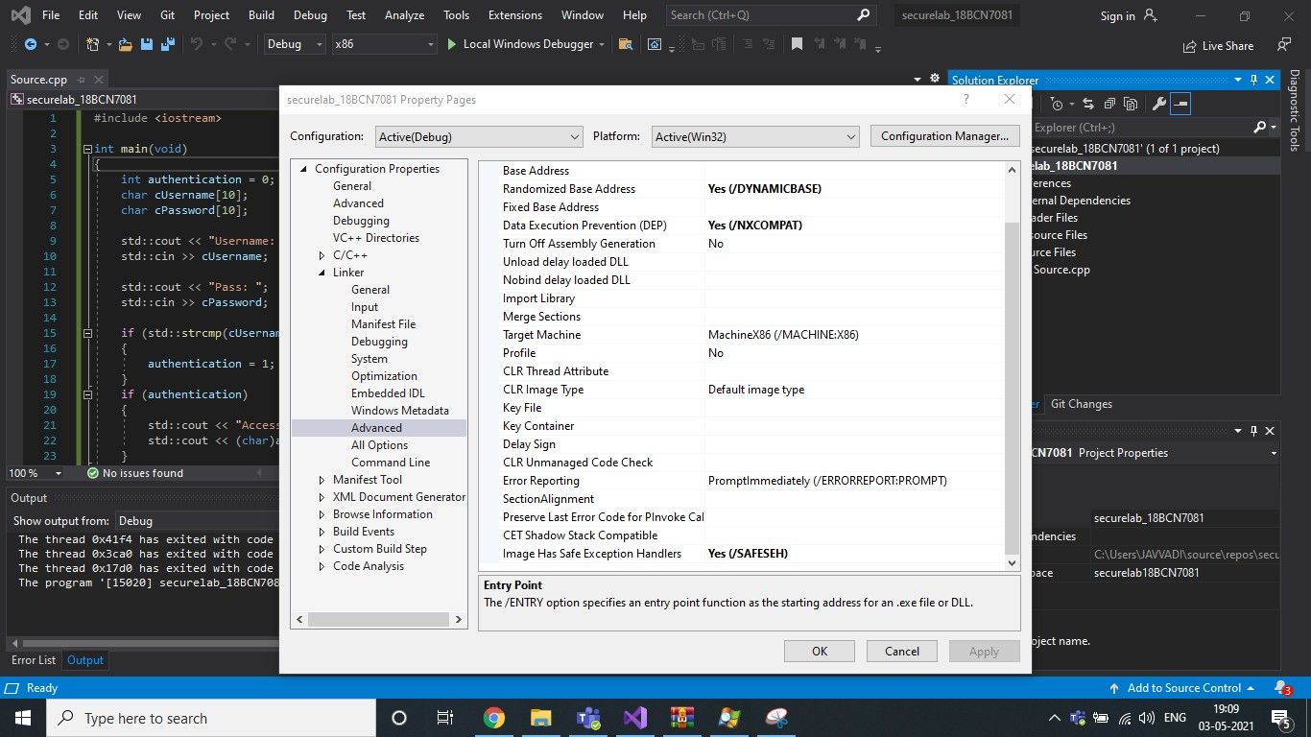

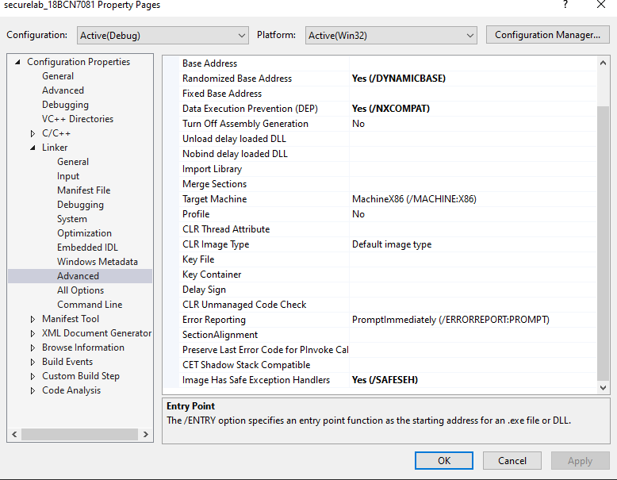

As you can see, I have enabled DEP, ASLR, SEH above.

I have Rebuilded my project and run the same and we can verify the status of DEP, ASLR, SEH.

# Verifying the DEP & ASLR status in Process Explorer after enabling

